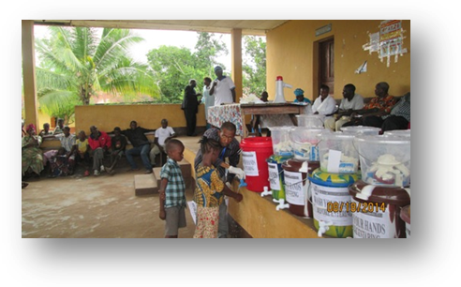
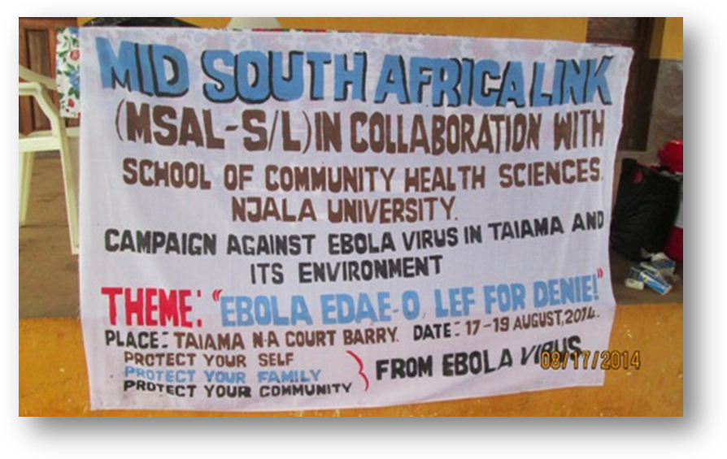
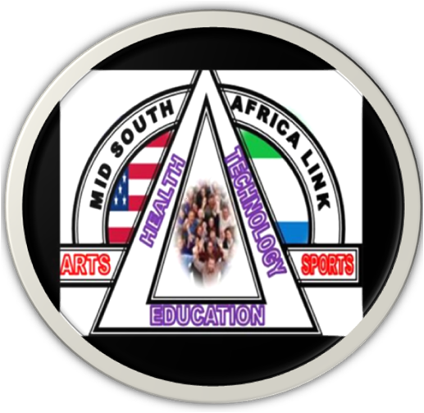
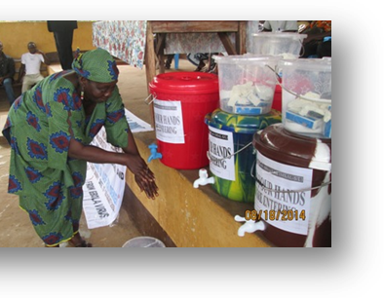
[Pick the date]
MSAL-S/LReport on
awareness raising, sensitization & donation of Preventive materials towards the fight against ebola virus

Targeted communities: Taiama & Njala communities

Date: august 16-17, 2014

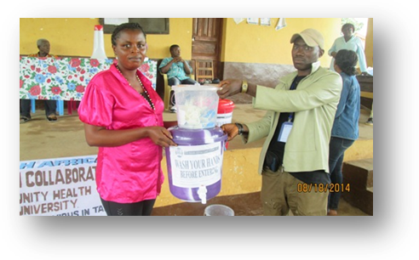
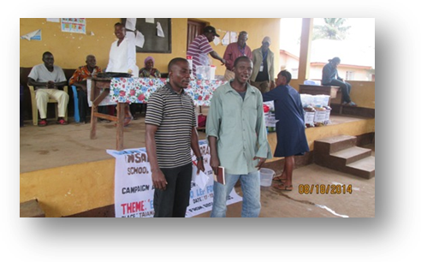
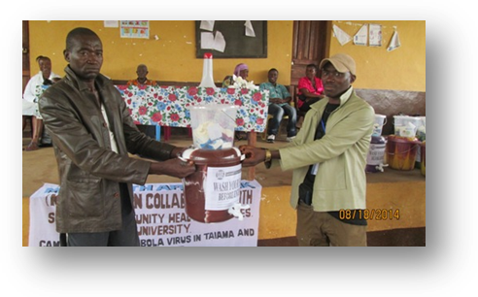

Submitted By: Mid South Africa Link Sierra Leone
Submission Date: August, 29, 2014
Introduction/Background.
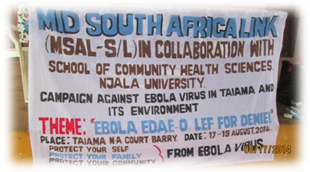
The deadly Ebola Virus was confirmed in the Guinean capital after series of tests were conducted on suspected cases, by government medical authorities in January 2014.This has since spread into neighboring Liberia and Sierra Leone in March and April, 2014 respectively.

Ebola virus disease (EVD) is considered one of the most aggressive viruses known to date in part because of its rapidity to kill, which can be within one week of exposure or three to four days from which the first symptoms become apparent. This leaves very little time for any treatment to act and save the sick individual.
Ebola is real, it kills. To date, a total of 815 cases have been tested (suspected and confirmed), laboratory confirmed cases number 296 confirmed deaths and 300 cases discharged. All of these cases occurred in Kailahun, Kenema, Bo, Moyamba, Port Loko and the Western Area. Over the past months, suspected cases have been rumored in the Northern part of the country. The Ebola virus disease is highly contagious and symptoms normally appear after an incubation period of 2 to 21 days. The fight against Ebola is of national concern.
Due to the above background, the Mid South Africa Link in Collaboration with the School of Community Health Sciences, Njala University Bo Campus and UMC Taiama Health Management Team has just ended a two days awareness raising, sensitization and donation of preventive materials to the Taiama and Njala communities.
The team believes that just after this sensitization the people of Taiama and its environs will definitely be aware of the Ebola Virus, and combine with concerted efforts to prevent Ebola from spreading the virus within Taiama and its environs.
The ceremony was climaxed with an opening prayer both in Christian and Muslim; representation was drawn from religious leaders, traditional leaders, youth groups, women groups, petty traders, churches and mosques within the Taiama and Njala Communities, Korie Chiefdom Moyamba District.

On the theme: “Ebola Edae o, lef for denie!”

Report Objective
- End of the campaign we expect people of Taiama and its environs to be aware, accept, and take preventive measures and report suspected cases of Ebola Virus to the nearest Health Centers.
- Report all death cases to the nearest Health Centre before burial.
- We expect people within the villages to stop eating bush meat and fruits eaten by bats.
- The bike (okada) riders and commercial drivers should stop carrying affected cases of Ebola virus patients; instead call the C.H.O or the Health Center to collect the patients.

Statement from Speakers
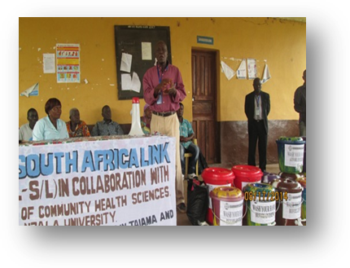
Making a statement, the Mid South Africa Link Sierra Leone Board representative Mr. Joe Amara said the aim of the awareness raising and sensitization is to let people of Taiama and Njala communities know that Ebola is real, and it is a national concern that requires every Sierra Leonean on board. He further informed the people, that is why a born origin from this community and the founder and Chief Executive Officer (CEO) of the Mid South Africa Link with other partners deem it necessary to stage and donate these preventives items to the people. He also said since the outbreak of Ebola the Founder Mr. Samuel H. Pieh keep on engaging the MSAL volunteers and others towards the fight against the Ebola Virus and kick it out of the country. He continued to encourage the people to take the preventive measures because the disease is real and has claimed the lives of many innocent useful citizens.

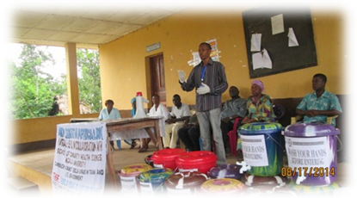
The national Representative Mr. Abraham Bah said, on behalf of MSAL-Sierra Leone they’re pleased associating with campaigns as a responsible organization, considering the amount of women & children that have contacted the disease within the district and the country at large, which has lost their lives. Mr. Bah thanked MSAL-USA and its partners for supporting the people of Taiama and Njala Communities and commended the School of Community Health Science Njala, for their active role in educating the people about the Ebola Virus and the preventative methods. He further told his audience that, they should listen to the medical practitioner on how to use the items and he also thanked all the people who were present at the center. He added that so many good things are on the way for the Taiama and Njala communities’ especially better water, sanitation and promoting good hygiene in the communities.
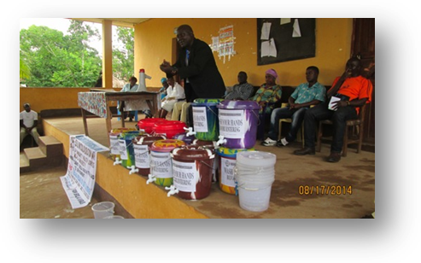
According to the Deen of School of Community Health Science Njala University, Dr. Bashiru Koroma, during the training session, he said because Ebola is a new disease in Sierra Leone, the University is concerned by the spread of the Virus across Sierra Leone and is strongly committed to continue working with MSAL-Sierra Leone and other partners in the emergency response to reduce the risk of the virus further spreading in the country.
In his presentation, he told his audience that, the easiest way of contracting the disease is through body contact, the eating of wild animals, bush meats especially monkeys, chimpanzees and bats. To prevent the spread of the virus, he said early identification and detection helps prevent the spread of the disease, so people should report suspected cases to the health centers, so that prompt medical attention will be taken.
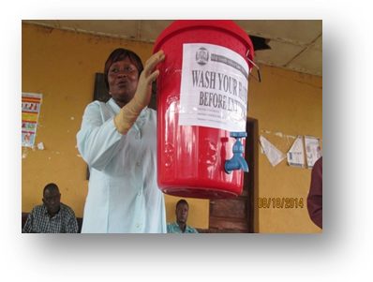
He then called on the religious leaders to join the campaign by sensitizing their congregations during Friday prayers and Sunday worships. Ebola, he went on, is a disease that comes from animals living in the forest. The use of chlorine and soap kills the virus. He encouraged the audience to take the advise which the medical team will give them on the prevention methods very seriously, so that the communities will be free from Ebola.
Making a statement on behalf of the UMC Health Center in Taiama, Sister Alice Konneh said Ebola is a very dreadful, deadly, and aggressive disease. She said Ebola and Lassa Fever belong to the same category, adding that it is transmitted through body contact. And, it is very simple to prevent if only it is detected early and reported for prompt medical attention. She further said the UMC Health Center is open to any sick person.
She further expressed thanks and appreciation to Mid South Africa Link, especially to the founder Mr. Samuel H. Pieh for his continuing support towards the UMC Health Center and the people of Taiama. She said the Health Center was in dire need of hand gloves, hand washing bucket and chlorine powder. She called on the people of Taiama both Christian and Muslim to continue sensitizing their congregations about the Ebola Virus.
Sister Alice, demonstrated the method of prevention by using chlorine and washed her hand in the bucket. She said the chlorine also have after effect if it is not used properly. She outlined the measurement for the chlorine and also informed the people that if they don’t have chlorine they could use ‘Saba Soap’ which would also be donated to them. In her closing remarks, she thanked the organizers for coming to the aid of the Taiama community, stating that people have been hearing about Ebola Virus, adding that the culture of denial was very high among our people. With the awareness raising, that would eventually help minimize the spread of the Virus.
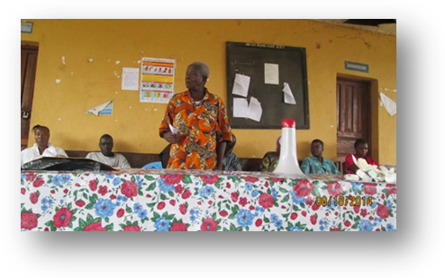
The Paramount Chief Representative Mr. Sidiki said this was the first organization to implement Ebola Sensitization in the chiefdom, and donated items to the people of Taiama. He thanked the founder Mr. Samuel H. Pieh for his continuing support towards the community. He informed the audience that Mr. Pieh has contributed immensely to the health, and well-being of the Taiama people and its environs.
Mr. Sidiki further extended warm greetings from the Paramount Chief, to the organizers and the people of Taiama foe leaving all important issues to come to get sensitization on the Ebola Virus. He encouraged the people to take all advise which would be given to them by the health officers. This measure, would help stop the spread of the Ebola Virus within the community. He also thanked Dr. Bashiru Koroma and Mr. Joe Amara for educating the people of Taiama about the risk towards the Ebola Virus.
Statement was made by different speakers like the religious leaders, women groups, youth groups, traditional leaders and police representative. Their statement also highlighted the method of prevention and worked towards the methods which would help reduce the spread of the Virus within their locality. Attendance numbered one hundred and twenty-two (122).
Distribution
The distribution of hand wash buckets, chlorine powder, hand gloves and ‘Saba soap’ to different youth groups, women groups, churches, mosques, market women and the police post, climaxed the programme.

Analysis of achievements
- The volunteers were committed and professional in their services delivery to the community.
- The turnout of people during the awareness raising and sensitization session was very much impressive.
- The participation of the UMC Health Center nurses during the town hall sensitization was commendable. The role played by the nurses was very much appreciated by the MSAL-S/L team.
- The practical evidences available were for instance, most of the speakers where very much happy for the timely sensitization and donations of preventive materials.
Analysis of challenges
The Mid South Africa Link (MSAL-Sierra Leone) encountered challenges as they carried out the Ebola Virus sensitization since its outbreak in the country. The demand for preventive materials within the community was very high and even the medical practitioners where at risk. Although resources were limited, medical staff all managed to cope and deliver adequately.

Conclusion
- The awareness rising, sensitization and the donation of preventive materials were full of rich experiences, educative and worth emulating with our operational community.
- A lot was learnt in addressing community related challenges.
- Discovered that when projects/programs/activities/initiatives meant for community development are community led, community owned, community driven, it become sustainable.
- I learnt that for every project to have community level impact base, the community should occupy the driving seat.

The Report was Submitted By:
Abraham Bah
National Representative
MSAL-Sierra Leone
1 Johns Street, Freetown

